**DAILY ONLINE ACTIVITIES SUMMARY**

|  |  |  |  |  |  |  |  |  |
| --- | --- | --- | --- | --- | --- | --- | --- | --- |
| **Date:** | **30/06/2020** | | | | | **Name:** | **Veekshith Shetty** | |
| **Sem & Sec** | **8th B** | | | | | **USN:** | **4AL16CS097** | |
| **Online Test Summary** | | | | | | | | |
| **Subject** | | **-** | | | | | | |
| **Max. Marks** | | **-** | | **Score** | | | **-** | |
| **Certification Course Summary** | | | | | | | | |
| **Course** | **Architecting Serverless solutions** | | | | | | | |
| **Certificate Provider** | | | **AWS** | | **Duration** | | | **3hr** |
| **Coding Challenges** | | | | | | | | |
| **Problem Statement:**  **Program to print binary number using recursion.** | | | | | | | | |
| **Status: Solved** | | | | | | | | |
| **Uploaded the report in Github** | | | | | **Yes** | | | |
| **If yes Repository name** | | | | | **Veekshith-Shetty** | | | |
| **Uploaded the report in slack** | | | | | **Yes** | | | |

Certification Course Details:

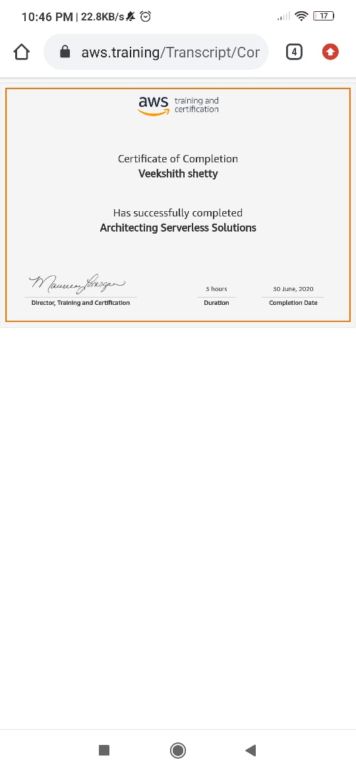

*Coding Challenges Details:*

def convertToBinary(n):

if n > 1:

convertToBinary(n//2)

print(n % 2,end = '')

dec = 34

convertToBinary(dec)

print()